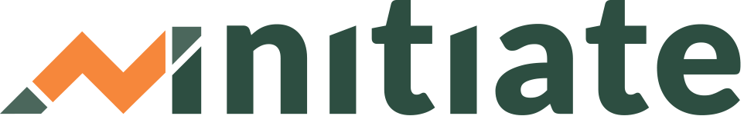
Learner Onboarding Checklist

Below are action items we encourage you to take to successfully onboard a new Learner/business owner to Initiate and your TA program.
Instructions: Add, delete, or specify certain actions depending on your organization’s internal process/policy. If possible, integrate the checklist into your CRM system.
NOTE: Delete above verbiage when done.
Tasks to complete for each business owner PRIOR to first TA meeting/call/site visit:
- Reach out to business owner via email: Introduce yourself and then briefly explain your role and TA program
- Update and attach the “Getting Started with Initiate: How Does it Work?” template and any other required documents
- Insert the [link] for the Entrepreneur Overview Video in the body of the email
- Set meeting day/time
- Invite Learner to Initiate or request that they create their account
- Confirm they were able to create an account and assign the Business Self-Assessment
- Review the Business Self-Assessment and identify additional resources that will be helpful to the business owner
- Plan first call agenda using the “TA Session Planning” template
Tasks to complete for each business owner DURING first TA meeting/call/site visit:
  - Review any organizational documents and TA relationship expectations
  - Talk through Business Assessment - find out what’s most important to the business owner
  - Navigate Initiate with them and highlight 1-2 additional resources that support their goals
  - Show Learners how to upload their work for templates (if Org. has premium subscription)
  - Create Action Plan in Initiate AND show Learner HOW to complete an Action item (they must check the box at the end of the resource to”complete” it).
Tasks to complete for each business owner AFTER first TA meeting/call/site visit:
- Review Activity tab in Initiate and follow up with Learner/business owner on progress of Action Plan
- Review action items that have been completed and look for any uploaded work
- Send next check-in invitation
- Plan agenda for the next check in
- See tool , titled, "TA Session Planning"
- Document notes/business updates from meeting in the organization’s CRM

