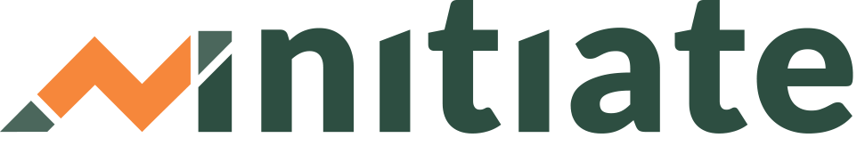
Templates Toolkit: TA Session Planning

Having a “lesson” plan is a common tool used in teaching. It is especially useful when introducing new content and technology at the same time. While all TA providers may have a different style of coaching/advising their business owners, utilizing a structured plan will ensure a standardized procedure that not only helps keep track of each TA session but also keeps the business owner engaged with planned content that is relevant to their specific business goals.
Instructions: Before starting a TA session, we recommend that you map out the following:
Session Objectives
This is the focus of each session and details an expected outcome for the session. This will help the Advisors stay focused on the business goals of the Learner throughout the session and give the Learner an understanding of what they will accomplish.
HINT: Be as specific as you can when it comes to objectives. Learners will stay engaged when they are addressing concerns related to their business and see progress or check off resources as completed.
Objective: Learner to create updated cash flow due to expected seasonal sales
Session Sequence and Timing (AGENDA)
This will outline the order of activities supporting how the objective will be met and how long each activity will last. This will help keep the TA provider focused and on track.
Session Sequence and Timing:
1. Review session Objectives and make and needed adjustments – 5 min.
2. Navigate through Initiate Dashboard with Learner – 5 min.
3. Demonstrate how to access the cash flow projections resource – 5 min.
4. Work through the resource together – 30 min.
5. Review challenges and/or questions – 5 min.
6. Talk through the Action Plan and next steps - 10 min.

HINT: For one-on-one sessions, plan max. 60 minutes.
For Group Training, max. 90 minutes.
Create an Action Plan
This summarizes next steps and creates accountability between the Advisor and Learner. It documents resources to complete helping the Learner identify what they should do next.
HINT: ALWAYS review the Learner’s completed work before the next session and if necessary, be prepared to offer targeted feedback, highlight their key take-aways and help them reprioritize their next steps.
Action Plan:
Using the “Assign Action Plan” function in the platform group together and assign one or more resources that support the Learner in creating an updated cash flow.
*SEE “FIRST SESSION WITH A NEW LEARNER” FOR FOR A SEQUENCE EXAMPLE FOR FIRST SESSION

